BRAC UNIVERSITY
Department of Computer Science and Engineering

Examination: Semester Midterm  Duration: 1 Hour 10 min | Semester: Summer 2022  Full Marks: 30
CSE 320: Data Communications

Answer the following questions.
Figures in the right margin indicate marks.

SET B

Name: | ID: | Section:

1. CO1 | a) | Complete the frames (X & Y) given below with appropriate port, IP and MAC addresses. The sender Host E has two applications running; one for email with port number 57150 and the other for accessing the web server with port number 52044. The frame X is intended for the BRACU Web server and frame Y is coming from the Email Server. (MAC addresses are alphabets and IP addresses are numbers)  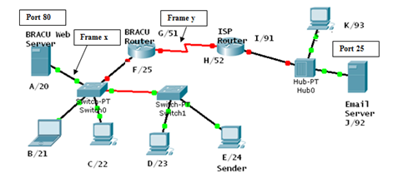  Frame X  S. MAC D.MAC S.IP D.IP S.Port D.Port Data Trailer  Frame Y  S. MAC D.MAC S.IP D.IP S.Port D.Port Data Trailer | 4
 | b) | Illustrate diagrammatically a hybrid topology with a ring backbone and three star networks consisting of 4 nodes at each hub. In the topology drawn, identify at least 2 possible problems or failures that could bring the whole or part of the network down and justify your answer. | 4
 | c) | Write the name of the TCP/IP model layers based on the following functionalities  - The layer processes information which helps us identify a network device.  - The layer responsible for transmitting data over fiber-optic.  - This layer translates messages from one language to another.  - User Datagram Protocol is used in this layer. | 2
2. CO2 | a) | If a periodic signal is decomposed into six sine waves with frequencies of 126, 348, 544, 896, 957 and 1900 Hz, what is its bandwidth? Draw the spectrum (frequency-domain representation), assuming all components have a maximum amplitude of 20 V. | 5
 | b) | Suppose the lower frequency of a channel is 1863 MHz, and the higher frequency of the channel is 1931 MHz. If the upper limit of the bit rate is about 38.7 Mbps, what is the signal to noise ratio in dB? | 5
3. CO2 | a) | Construct a mapping table for a 3B/4B Block Coder with the following rules. You can ignore the control sequences, just construct the table for encoded sequences. While choosing the encoded sequences, make sure to follow the rules specified below:  - The encoded sequences can’t have three consecutive zeros (0) in the table  - If first bit is 1, it has to be followed by a 0 (i.e. You can consider encoded sequences that start with “10”)  - If the first bit is 1, it cannot be followed by a 1 (i.e. Ignore encoded sequences that start with “11”)  - “0111” is reserved for control sequence and can’t be used in the mapping. | 5
 | b) | The following table depicts a sampled analog signal for digital signal representation. By applying the concept of Pulse Code Modulation, assume there will be 3-bit code words for each sampled amplitude. Show the normalized quantized value and quantization code for the given analog signal value at different time stamps. Assume that the sampling amplitudes are between -20V to +20V.  Time Analog Signal Value (V)  0 -3.3  1 9.4  2 15.7  3 -13.2 | 5

---END---

